Music Development Plan
Potten End CofE Primary

Overview
Detail | Information
Academic year that this summary covers | 2025-26
Date this summary was published | September 1st 2025
Date this summary will be reviewed | September 1st 2026
Name of the school music lead | Abby Deacon
Name of school leadership team member with responsibility for music (if different) | Denise Kennedy
Name of local music hub | Herts Music Service

This is a summary of how our school delivers music education to all our pupils across three areas – curriculum music, co-curricular provision and musical experiences – and what changes we are planning in future years. This information is to help pupils and parents or carers understand what our school offers and who we work with to support our pupils’ music education.

Part A: Curriculum music
Music and singing are integral to the life of a Potten End CE Primary School child. We aim to provide a vibrant musical experience for all children. We provide opportunities for all children to create, play, perform and enjoy music; to develop the skills to appreciate a wide variety of musical forms and to begin to make judgements about the quality of music. Children are given further opportunities to learn and play musical instruments as part of the curriculum and in private lessons.
Through the curriculum pupils will:
• Gain enjoyment, self-confidence and a sense of achievement through participating in musical activities.
• Be aware of, understand and respond appropriately to the rich variety of sounds in their environment and particularly to those organised arrangements of sounds called music.
• Acquire musical skills and understanding of musical concepts through primarily active listening, then performing and composing.
• Develop their capacity to express ideas and feelings through the medium of sound.
Potten End CE uses Kapow to support the delivery of music from EYFS to year 6. Every week, during one half term, each class has a music lesson which develops music skills in lessons and singing in in assemblies.
To ensure a good progression of knowledge and skills, teachers use the Kapow scheme of work as the basis for lesson planning.
The programme provides a variety of opportunities for children to develop their understanding of musical vocabulary, of skills and to play instruments.
In each year group there are planned opportunities to use instruments as part of music lessons e.g. glockenspiels, drums, tambourines.
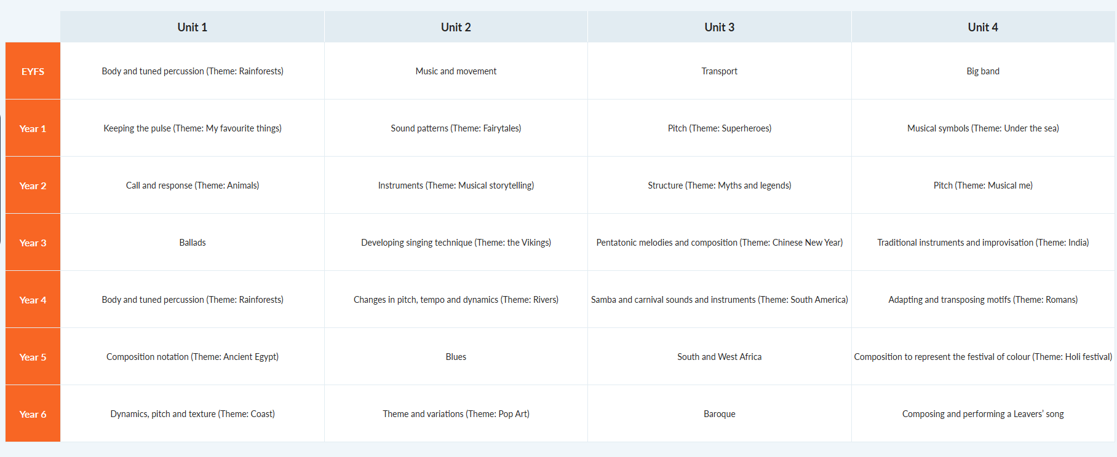
The curriculum and music programme has been shared with staff members to use and ensure coverage of music objectives are taught across the year group. These lessons and objectives are taken from the Kapow scheme of work. The current overview for music:

Part B: Extra-curricular music
At Potten End CofE Primary we offer the following music tuition in one to one sessions:
Provided by Ruth Seodi: Keyboard - Charges for £25 per lesson
Provided by Oliver: Guitar – Charges £20 per lesson
Choir for Years 3-6
We have a school choir that takes place once a week. The choir is provided with many opportunities to perform either in school at music performances but also outside of school.

Part C: Musical experiences
This is about all the other musical events and opportunities that we organise, such as singing in assembly, concerts and shows, and trips to professional concerts.
We hold a music assembly once a week for R-6. At this assembly children are taught a range of religious songs.
We start every act of worship with a song. Worship is 4 days a week.
We hold end of term music assemblies where children perform in front of parents and peers. The choir and recorders also performs.
We hold a whole school end of term event for the choir and classes to share their music with parents or wider family.
Year 5 attended Wembley Arena for the Young Voices concert. Parents fund the experience.
We organise a pantomime in December. This is for Reception to Year 6. Our PTA fund this.
Each class performs a class assembly to the rest of the school and to their parents. Music and singing is included in the class assemblies.
Reception to Year 2 perform a Christmas production that involves music and singing. Year 6 perform an end of year production that involves music and singing.
We also hold House events which incorporate playing instruments and singing.

In the future
This is about what the school is planning for subsequent years.
In future years, our Music Development Plan aims to achieve the following:
- Introduction of a wider range of instruments on offer for small group or individual lessons.
- Further develop performance opportunities for our young musicians throughout the school year.
- Further develop engagement in extra-curricular music for Pupil Premium and SEND children

