Summer Term
Shadow Puppets
Artists
Lotte Reiniger  – a German film director and the foremost pioneer of silhouette animation |  | Matisse  – French visual artist. |  | Phillipp Otto Runge,  – German artist, draftsman, painter, and color theorist
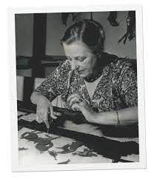  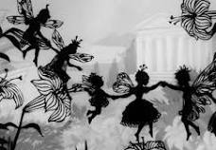 |  | 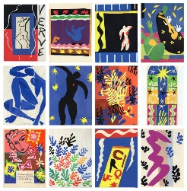  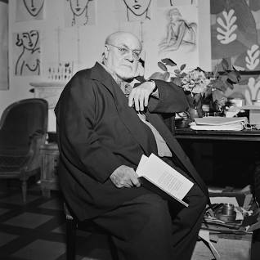 |  | 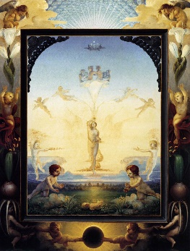  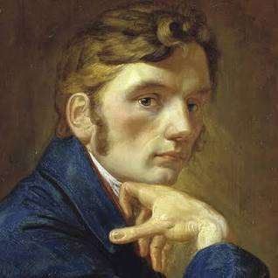
Artistic Skills
- To see how a variety of artists and craftspeople use their interest in cut outs to generate imagery.
- To share my response to their work with my classmates.
- To use my curiosity to think about how I might adapt techniques and processes to suit me.
- To use my sketchbook to record, generate ideas, test ideas and reflect.
- To make a shadow puppet thinking about how the qualities of the materials used affect the final outcome.
- To manipulate the materials using tools so that the puppets made have character and expression.
- To make puppets move in simple ways by articulating them.
- To work with my peers to create a collaborative experience.
- To share my work, as a team, and share and listen to feedback.
- To give my feedback to the work of other teams, and appreciate the differences and similarities of their work to ours.

To photograph or film the puppets and performance.
Vocabulary (Key Words)
Paper cutting  Cut outs | Shadow puppets |  | Performance  Narrative  Character |  | Present  Share  Reflect  Respond  Articulate  Feedback  Crit  Similarities  Differences
At the end of this unit, you will have learnt how to:
- Use the art of paper cutting, and understand how it can be used and adapted to create shadow puppets.
- Explore shadow puppets from a historical and contemporary perspective before making own puppets, exploring line, shape, form and character.

