Spring 1
Exploring Identity
Artists
Njideka Akunyili Crosby  – uses historical, political and personal references in her art. |  | Thandiwe Muriu  – portraits that are powerful symbols of beauty and pride. |  | Mike Barrett  – digital artist and photographer | Yinka Shonibare  – sculpture, painter and photographer – examining race, cultural identity and class through his art.
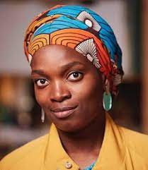  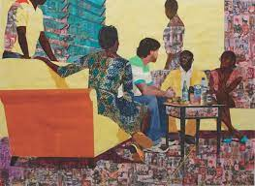 |  | 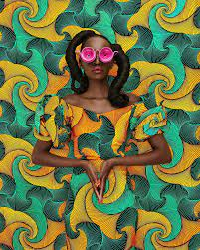 |  | 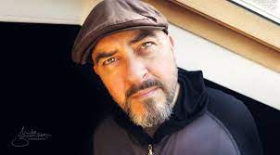  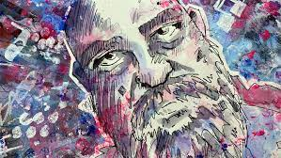 | 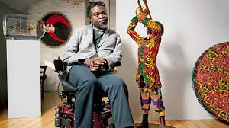  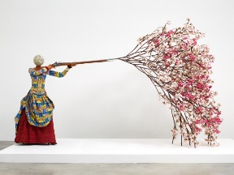
Artistic Skills
- To see how artists explore their identity by creating layered and constructed images.
- To share my response to their work with my classmates.
- To use my curiosity to think about how I might adapt techniques and processes to suit me.
- To use my sketchbook to record, generate ideas, test, reflect and record.
- To work digitally or physically to create a layered portrait to explore aspects of my identity, thinking about line, shape, colour, texture and meaning.
- To share my work with my classmates, articulate how I feel about the journey and outcome.
- To listen to feedback from my classmates and respond.
- To appreciate the work of my classmates and to reflect upon the differences and similarities of their work (and experience) to mine.
- To share my response to their work.

To take photographs of my artwork, thinking about lighting, focus and composition.
Vocabulary (Key Words)
Identify  Layer  Constructed | Layering  Portraiture |  | Digital art  Physical |  |  | Present  Share  Reflect  Respond  Articulate  Feedback  Crit  Similarities  Differences
At the end of this unit, you will have learnt how to:
- Explore how artists embrace aspects of their experience of life – using their background, culture, race, gender, and interests to inform and shape their artwork.

