Autumn 1
2D Drawing to 3D Making
Artists
Lubaina Himid – artist and curator |  | Claire Harrup – Illustrator and Printmaker
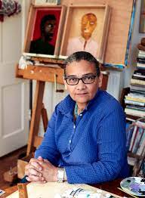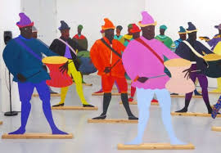 |  | 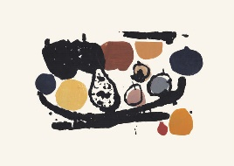  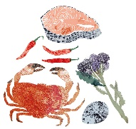  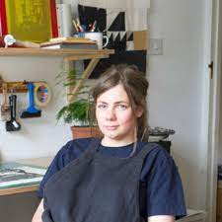
Artistic Skills
- To explore artists who use their drawing skills to make objects, and I can share my responses to their work, thinking about their intention and outcome.

To use my sketchbook to record and reflect, collecting the ideas and approaches I like which I see other artists use.

To use line, mark making, tonal values, colour, shape and composition to make my work interesting.

To use negative space and the grid method to help me see and draw.

To explore typography and design lettering which is fit for purpose.

To transform my drawing into a three dimensional object.

To share my work with others, and talk about my intention and the outcome. To listen to their response and take their feedback on board.

To appreciate the work of my classmates. To listen to their intentions and share my response to their work.

To photograph my three dimensional work, thinking about presentation, lighting, focus and composition.
Vocabulary (Key Words)
2D drawing  3D drawing  Packaging  Negative space | Grid method  Scaling up  Net  Typography | Graphic design  Collage  Structure  Balance | Present  Share  Reflect  Respond  Articulate  Feedback  Crit  Similarities  Differences
At the end of this unit, you will have learnt how to:
- Consider how 2 dimensional drawings might relate / transform to 3 dimensional making

