Autumn term
Typography and Maps
Artists
Louise Fili | Chris Kenny |  | Paula Scher
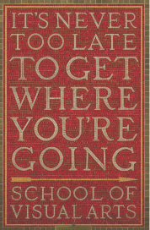  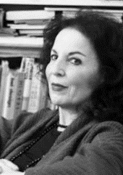 | 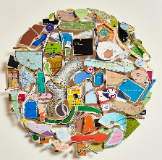  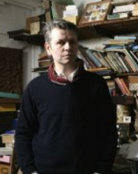 |  | 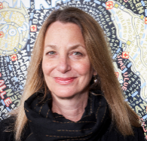  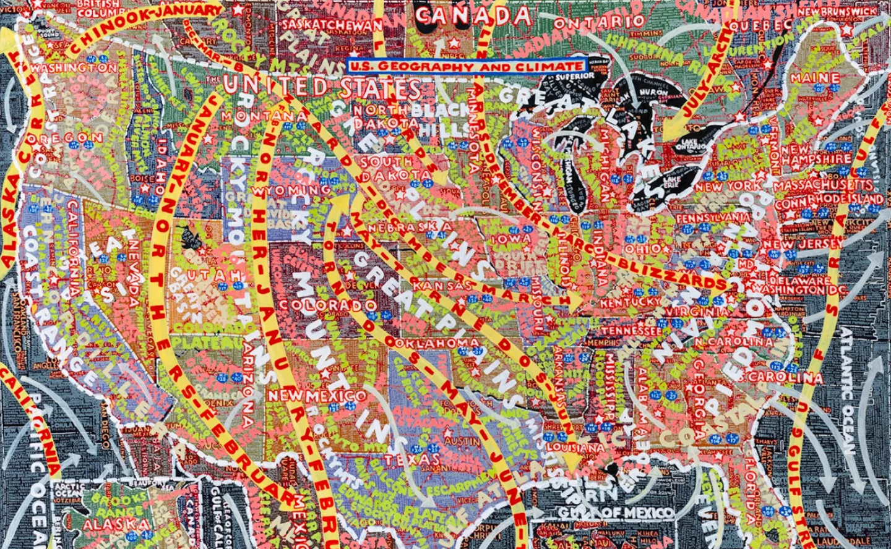
Artistic Skills
Typography |  |  | Use cutting, collage and drawing to create own letters with meaning.
Maps |  |  | Develop strong mark making skills to make drawings appear visually stronger over a background.
Vocabulary (Key Words)
Typography |  | Maps
Typography, Lettering, Graphics, Design, Communicate, Emotions, Purpose, Intention, Exploratory, Visual Impact. |  | Pictorial Maps, Identity, Symbols.
At the end of this unit, you will have learnt how to:
Use typography and powerful drawing skills to create a visual map.

Autumn term
Typography and Maps
Artists
Louise Fili | Chris Kenny |  | Paula Scher
Artistic Skills
Typography |  |  | Use cutting, collage and drawing to create own letters with meaning.
Maps |  |  | Develop strong mark making skills to make drawings appear visually stronger over a background.
Vocabulary (Key Words)
Typography |  | Maps
Typography, Lettering, Graphics, Design, Communicate, Emotions, Purpose, Intention, Exploratory, Visual Impact. |  | Pictorial Maps, Identity, Symbols.
At the end of this unit, you will have learnt how to:
Use typography and powerful drawing skills to create a visual map.

