Summer term
Set design
Artist

Rae Smith
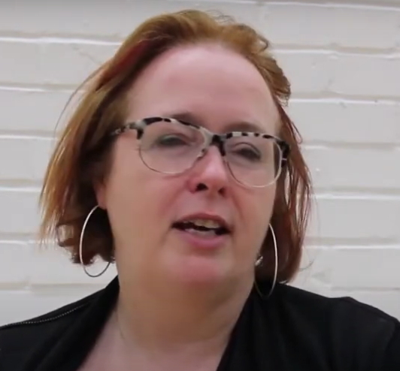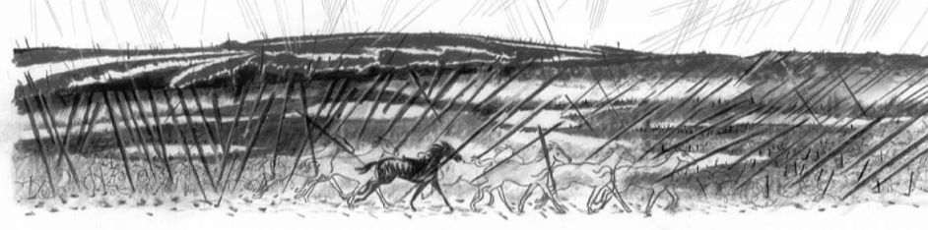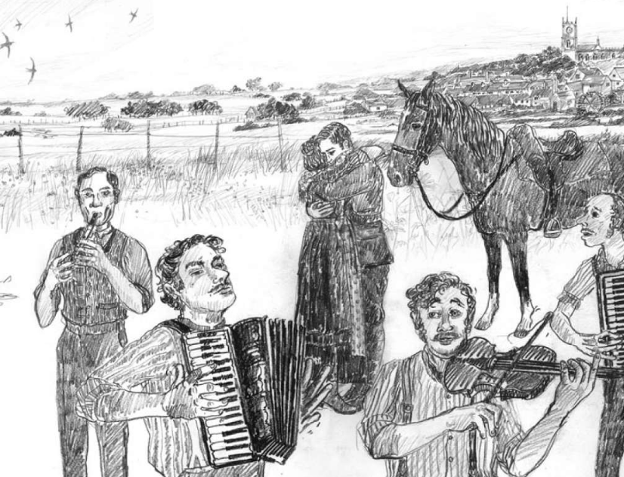

Artistic Skills
Skills using charcoal – running, using an eraser, creating darker lines, using dots, dashes, solid lines, broken lines, add white lines using chalk
Designing through making – consider backdrop, flats, props, structure, materials, and shapes – experiment and improve. Photograph sets considering light.
Reflecting and responding to each other’s work considering what we like most and how we could do things differently
Vocabulary (Key Words)
Set Design, Theatre, Animation, Model,
Design Through Making, Imaginative, Response, Stimulus, Interpretation, Vision, Mood, Drama, Narrative
Lighting, Composition, Foreground, Background,
Present, Share, Reflect, Respond, Articulate, Feedback, Similarities, Differences
At the end of this unit, you will have learnt how to: Create a dramatic set in response to a text.

