Spring 1
Mixed Media: Land and City Scapes
Artists
Vanessa Gardiner | The Shoreditch sketcher | Kitty Jones
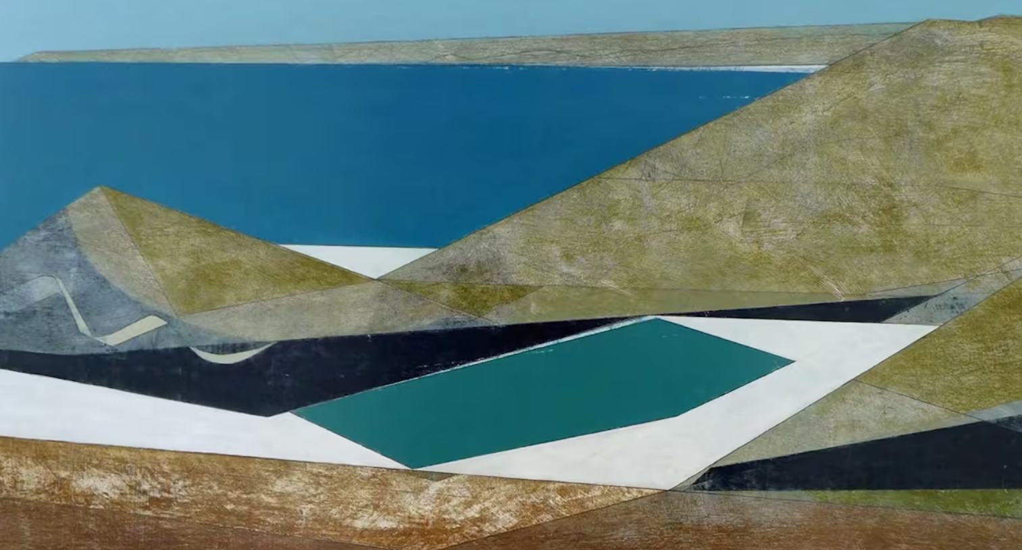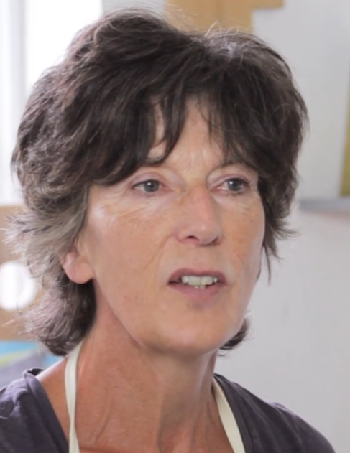 | 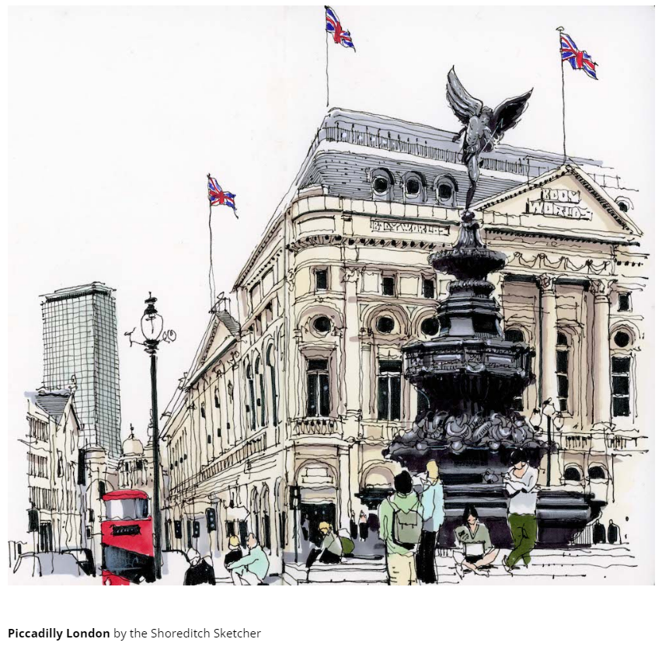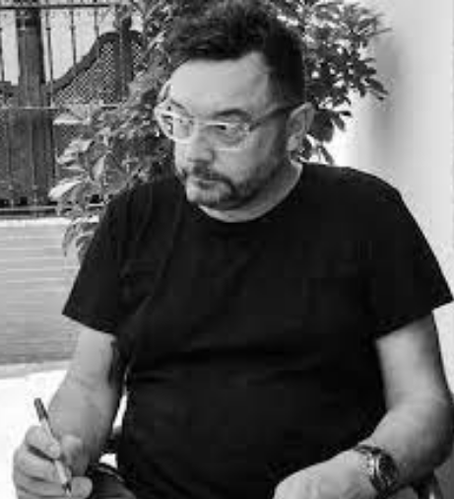 | 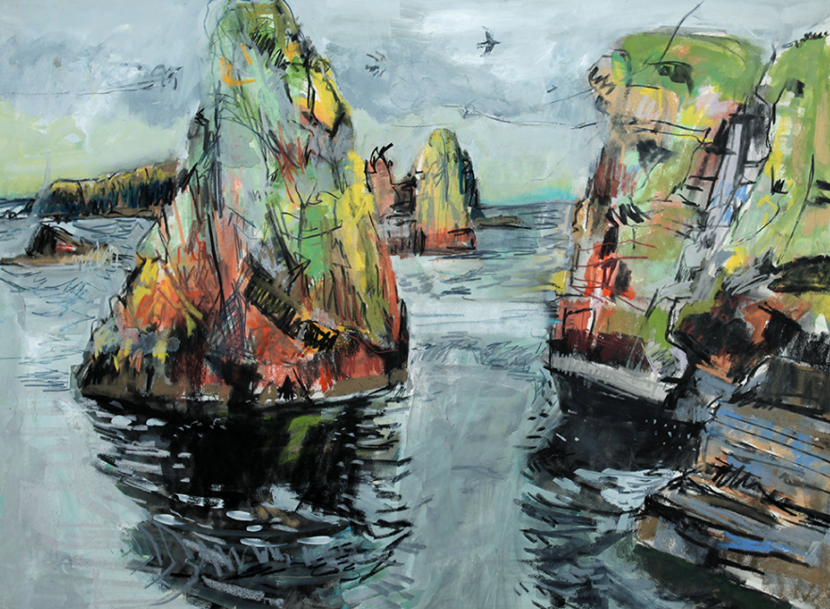  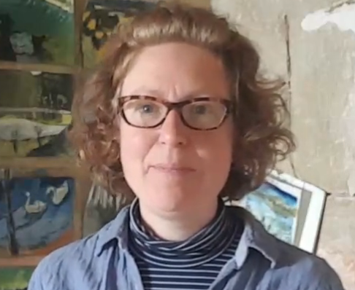
Artistic Skills
Understand and respond to how artists use a variety of media in different combinations to create their work.
Experiment with materials and media, combining them to see what happens. Taking artistic risks without fear of making mistakes.
Reflecting and responding to each other’s work considering what we like most and how we could do things differently
Vocabulary (Key Words)
Mixed media, Landscape, Cityscape layers, charcoal, pastels, watercolours, visual notes, impact, Capture, Composition, Present, Share, Reflect, Respond, Similarities, Differences.
At the end of this unit, you will have learnt how to
Effectively use a mix of different media to create an energetic land or city scape.

Spring 1
Mixed Media: Land and City Scapes
Artists
Vanessa Gardiner | The Shoreditch sketcher | Kitty Jones
Artistic Skills
Understand and respond to how artists use a variety of media in different combinations to create their work.
Experiment with materials and media, combining them to see what happens. Taking artistic risks without fear of making mistakes.
Reflecting and responding to each other’s work considering what we like most and how we could do things differently
Vocabulary (Key Words)
Mixed media, Landscape, Cityscape layers, charcoal, pastels, watercolours, visual notes, impact, Capture, Composition, Present, Share, Reflect, Respond, Similarities, Differences.
At the end of this unit, you will have learnt how to
Effectively use a mix of different media to create an energetic land or city scape.

