Autumn 1 term
Storytelling through Drawing
Artists
Laura Carlin: An illustrator |  | Shaun Tan: A graphic novelist and author
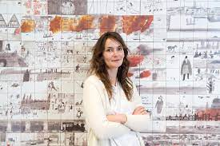  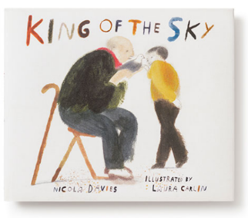 |  | 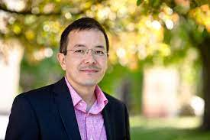  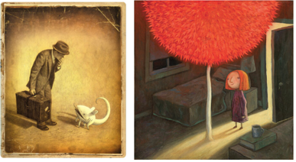
Artistic Skills
- To explore the work of artists who tell stories through imagery
- To respond to the work of illustrators and/or graphic novelists, “reading” the visual images and sharing my thoughts.
- To create sketch books to record my observations and use them to review and revisit ideas
- To use a sketchbook to generate ideas about how I might respond to a piece of poetry or prose.
- To improve my mastery of art and design techniques, including drawing and painting with a range of materials [for example, pencil, charcoal, paint]
- To use line, shape, and colour using a variety of materials to test my ideas.
- To think about how I might use composition, sequencing, mark making and some text in my drawings.
- To create a finished piece which contains sequenced images to describe a narrative.
Vocabulary (Key Words)
Illustration  Inspiration  Interpretation Respond  Graphic Novel  Illustrator | Poetry  Stage  Arrange  Composition Sequencing  Visual Literacy Narrative | Line  Quality of line  Line Weight  Mark Making  Medium  Graphite  Ink  Watercolour | Present  Share  Reflect  Feedback  Similarities  Differences
At the end of this unit, you will have learnt how to:
- Tell stories through drawing.
- Use text within our drawings to add meaning.
- Sequence drawings to help viewers respond to our story.
- Use line, shape, colour and composition to develop evocative and characterful imagery.

