Summer term
Festival Feasts
Artists
Claes Oldenberg |  | Lucia Hierro |  | Nicole Dyer
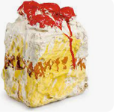 |  | 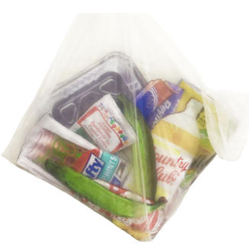 |  | 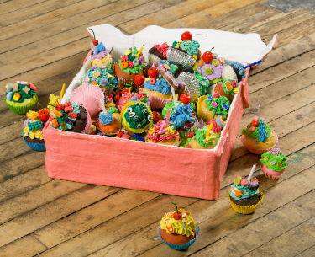
Artistic Skills
- To explore the work of artists who are inspired by food and share my responses with the class.
- To use my sketchbook to record and reflect how the artist’s work makes me feel.
- To use my sketchbook to draw food using a variety of media, drawing from still images and from life, exploring how I can use line, shape, and colour to capture the texture and form of the food.
- To make a sculpture of food, understanding that by working in 3d my sculpture will be seen from different viewpoints.
- To explore and experiment using “Design through Making”, and I can discover how I can transform and construct with different materials to make my sculpture.
- To see how my own sculpture can form part of a larger artwork, and how we can all find inspiration in each others’ ideas.
- To present my work as part of a larger artwork, and share my response to my own work and also to the work of my peers.
Vocabulary (Key Words)
Viewpoint, Relationship 2D 3D, Transform, Graphics, Design Through Making, Construct, Contribute, Artwork, Installation | Surface, Fabric, Texture |  | Present, Share, Reflect, Respond, Articulate, Feedback, Crit, Similarities, Differences |  | Photograph, Lighting, Focus, Composition
At the end of this unit, you will have learnt how to:
- Respond to a creative stimulus through lots of different media (paper, pen, paint, modelling materials and fabric) to work towards drawing, painting, collage, and sculpture.
- Use our knowledge and curiosity of line, shape, colour and form to make playful and inventive art.
- Make an individual artwork which contributes to a larger shared piece, or work on a shared artwork.
- Make art fun and joyful, and that we can find subject matter which inspires us all and brings us together.

