Autumn 2 term
Exploring pattern
Artists
Shaheen Ahmed |  | Rachel Parker
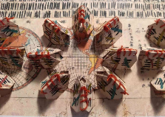 |  | 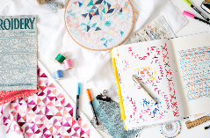
Artistic Skills
- To relax into making a sensory drawing using a pencil, making marks on the page without having a predefined outcome.
- To explore the work of artists who are inspired by pattern
- To explore how I can make drawings inspired by ‘rules’
- To generate lots of different types of patterns
- To explore the work of a surface pattern designer and make my own repeating pattern, exploring colour, shape and composition.
- To present and share my work. To reflect and share my thoughts with others. To listen to the reflections of my classmates and feedback on their work.
Vocabulary (Key Words)
Pattern, Sensory, Playful, Mindful, Exploratory, Point, Line, Rhythm, Shapes, Circles, Ovals, Curves | Purpose, Decorative, Pleasing, Aesthetic,  Generate, Explore, Experiment, | Surface Pattern, Repeating, Composition, Juxtaposition, Collage, Arrange | Present, Share, Reflect, Respond, Articulate, Feedback, Crit, Similarities, Differences,
At the end of this unit, you will have learnt how to:
- Understand that the act of making drawings can be mindful.
- Use line, shape and colour to create patterns.
- Use folding, cutting and collage to help us create pattern.
- Create repeated patterns to apply to a range of products or outcomes.

