Summer Term - Natural Forms, working in 3-dimensions
Artists
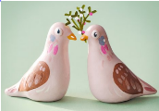  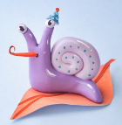 |  |  | 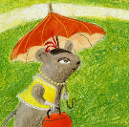  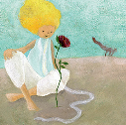 |  | 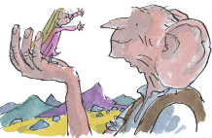  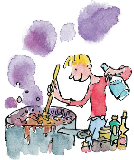
Rosie Hurley - sculptor |  |  | Inbal Leitner - illustrator |  | Quentin Blake- illustrator (Roald Dahl – author)
Artistic Skills
Drawing | Control the types of marks made with pencils, pens, and water colours
Sculpting | Understand the properties of clay in order to shape it in response to a specific design
Collage | Use a range of materials such as feathers, tissue paper and eyes to develop the character of your sculpture
Vocabulary (Key Words)
Drawing |  |  |  | Colour wash |  | Sculpture
Illustrate |  | Gesture |  | Construct |  | Characterisation
At the end of this unit, you will have learnt how to…..

- Develop your techniques, including your control and use of materials, with creativity, experimentation and an increasing awareness of different kinds of art, craft and design.
- Use sketch books to record your observations and use them to review and revisit ideas
- Improve your mastery of art and design techniques, including drawing, painting and sculpture with a range of materials such as pencil, pen, watercolour, clay
- Explore the work of great artists, architects and designers.

