Autumn Term
Gestural drawing with charcoal:
How can we use gestural drawing with charcoal to make drawings full of energy and drama?
Artists
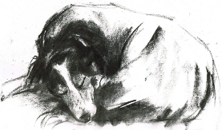  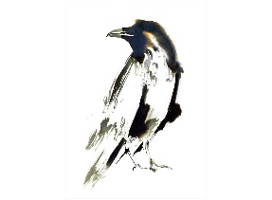  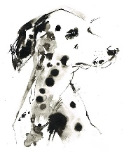 |  | 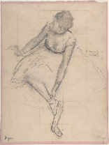  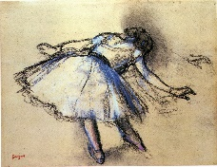  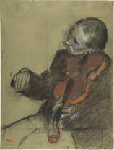
Laura McKendry |  | Edgar Degas
Artistic Skills
Drawing - Control the types of marks made with charcoal
Mark Making - Using lines, dots, marks, patterns and textures to create artwork
Vocabulary (Key Words)
Lighting | Composition |  | Tone
Positive & Negative Shapes | Chiaroscuro |  | Silhouette
Trace | Focus |  | Expressive
At the end of this unit, you will have learnt how to:

• Use gestural marks to make work.
• Use the expressive marks we make to create a sense of drama.
• Move around when we draw.
• Use light to make our subject matter more dramatic, and to use the qualities of charcoal to capture the drama.

Autumn Term
Gestural drawing with charcoal:
How can we use gestural drawing with charcoal to make drawings full of energy and drama?
Artists
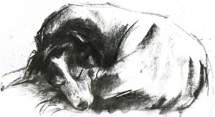 |  | 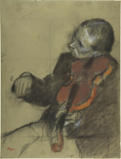
Laura McKendry |  | Edgar Degas
Artistic Skills
Drawing - Control the types of marks made with charcoal
Mark Making - Using lines, dots, marks, patterns and textures to create artwork
Vocabulary (Key Words)
Lighting | Composition |  | Tone
Positive & Negative Shapes | Chiaroscuro |  | Silhouette
Trace | Focus |  | Expressive
At the end of this unit, you will have learnt how to:

• Use gestural marks to make work.
• Use the expressive marks we make to create a sense of drama.
• Move around when we draw.
• Use light to make our subject matter more dramatic, and to use the qualities of charcoal to capture the drama.

