Autumn Term
Cloth, Thread, Paint
How can create evocative land and seascapes using fabric, paint and thread? How can we draw upon our mark making skills when working with thread?
Artists
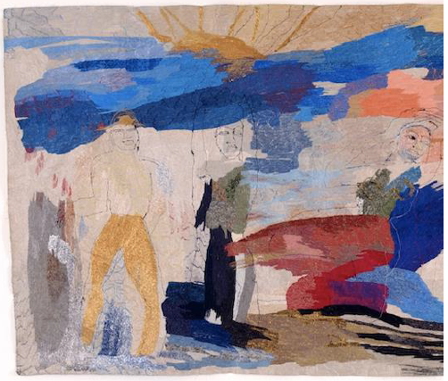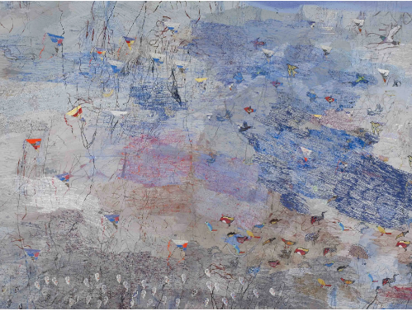 |  | 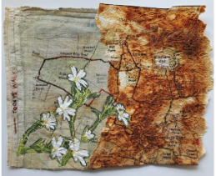  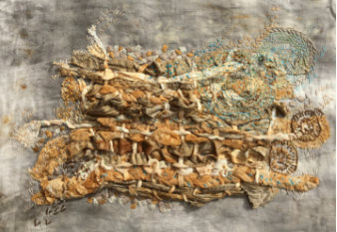
Alice Kettle |  | Hannah Rae
Artistic Skills
Mark making - Using lines, dots, marks, patterns and textures to create artwork with paint, fabric and thread
Impasto – Laying on paint (or pigment) thickly so that it stands out from a surface
Vocabulary (Key Words)
Mixed Media | Colour Mixing |  | Tension
Background | Impasto |  | Repeated
Foreground | Gesture |  | Pattern
At the end of this unit, you will have learnt how to:

• Combine art and craft using painting and sewing together to make art.
• Use the unique qualities of two media together (paint and thread) to build an image.
• Transfer mark making skills from drawing (with charcoal) to use in sewing.
• Use traditional materials and techniques in new ways to make art.

Autumn Term
Cloth, Thread, Paint
How can create evocative land and seascapes using fabric, paint and thread? How can we draw upon our mark making skills when working with thread?
Artists
Alice Kettle |  | Hannah Rae
Artistic Skills
Mark making - Using lines, dots, marks, patterns and textures to create artwork with paint, fabric and thread
Impasto – Laying on paint (or pigment) thickly so that it stands out from a surface
Vocabulary (Key Words)
Mixed Media | Colour Mixing |  | Tension
Background | Impasto |  | Repeated
Foreground | Gesture |  | Pattern
At the end of this unit, you will have learnt how to:

• Combine art and craft using painting and sewing together to make art.
• Use the unique qualities of two media together (paint and thread) to build an image.
• Transfer mark making skills from drawing (with charcoal) to use in sewing.
• Use traditional materials and techniques in new ways to make art.

