Year 2 - Spring Term - Exploring the World Through Mono Print
Artists
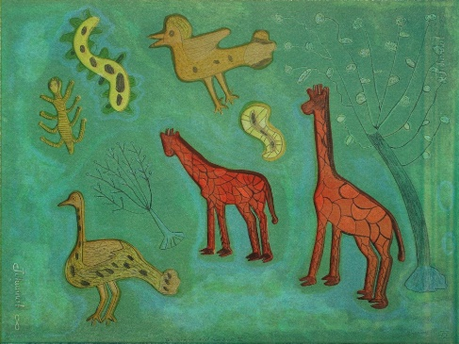 |  | 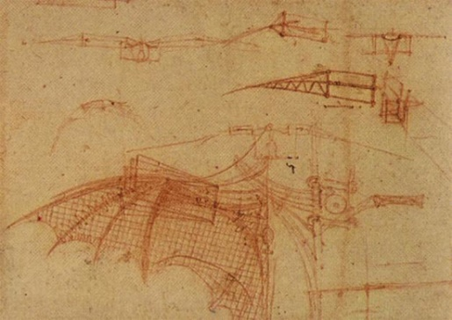
Xgaoc’o X’are |  | Leonardo Di Vinci
Artistic Skills
Drawing |  | Control the types of marks made with pencils, pens and pastels
Printing |  | Explore mono printing, make simple marks on rollers and printing pallets
Vocabulary (Key Words)
Drawing |  | Printing
line, mark, shape, colour |  | pressure, line, mark, page, mark making, tone, shape
Materials
Graphite pencils, Oil pastels, Wax crayons, Handwriting pens, Tracing paper, Carbon copy paper |  | reflect, present, share, discuss, feedback
At the end of this unit, you will have learnt how to…
Used carbon copy paper to create a mono print.
Evaluation Questions.
What have you done?  What have you learnt?  What could you do differently? | How did you do it?  How well did it work?  How could you improve? |  | Why did you do it?  Why is it effective?  Why would you improve it?

