Year 2 Autumn Term - Explore and Draw
Artists
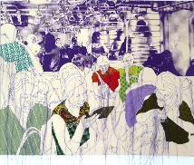 | 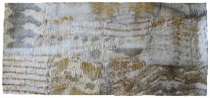 |  | 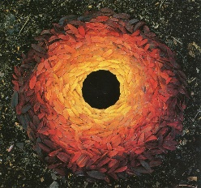
Rosie James | Alice Fox |  | Andy Goldsworthy
Artistic Skills
Drawing |  |  | Control the types of marks made with pencils, pens, charcoal and pastels.
Vocabulary (Key Words)
Drawing |  |  | Printing
explore, collect, imagine, present, re-present, arrange, composition, photograph, focus, light, shade, observational drawing, close study, intention |  |  | pressure, line, mark, page, mark making, tone, shape
Materials
wax resist, graphite, watercolour, brusho, pencil |  |  | reflect, present, share, discuss, feedback
At the end of this unit, you will have learnt how to…
Draw a real world object using mark making.
Evaluation Questions
What have you done?  What have you learnt?  What could you do differently? |  | How did you do it?  How well did it work?  How could you improve? |  | Why did you do it?  Why is it effective?  Why would you improve it?

Year 2 Autumn Term - Explore and Draw
Artists
Rosie James | Alice Fox |  | Andy Goldsworthy
Artistic Skills
Drawing |  |  | Control the types of marks made with pencils, pens, charcoal and pastels.
Vocabulary (Key Words)
Drawing |  |  | Printing
explore, collect, imagine, present, re-present, arrange, composition, photograph, focus, light, shade, observational drawing, close study, intention |  |  | pressure, line, mark, page, mark making, tone, shape
Materials
wax resist, graphite, watercolour, brusho, pencil |  |  | reflect, present, share, discuss, feedback
At the end of this unit, you will have learnt how to…
Draw a real world object using mark making.
Evaluation Questions
What have you done?  What have you learnt?  What could you do differently? |  | How did you do it?  How well did it work?  How could you improve? |  | Why did you do it?  Why is it effective?  Why would you improve it?

