
Potten End CE Primary
Handwriting Policy

Introduction

At Potten End CE Primary School, handwriting is considered to be a vital skill that underpins children’s confidence and achievement in writing. Fluent, legible handwriting enables pupils to express their ideas clearly, supports spelling and composition, and contributes to pride in presentation. This policy sets out our approach to teaching handwriting across the school, ensuring consistency and progression within and between year groups.

Accountability

This policy outlines the learning, teaching, organisation and management of handwriting at Potten End CE Primary School.

The implementation of this policy is the responsibility of all teaching staff. The responsibility for monitoring and review rests with the English leader.

Aims and Values / INTENT
At Potten End CE Primary School, our approach to handwriting ensures that:

  - All pupils are taught correct letter formation and fluent handwriting.
  - All pupils meet National Curriculum requirements for handwriting.
  - Enjoyment and motivation in writing are fostered by removing barriers caused by poor handwriting.
  - A structured, cumulative programme of teaching handwriting is in place from Reception onwards

IMPLEMENTATION

Key Principles of Our Approach to Handwriting
  - Explicit teaching: Handwriting is taught a minimum of x3 a week in short, focused sessions.
  - Visualisation: Pupils learn to “visualise to memorise” using picture hooks and phrases from the Read Write Inc
‘Letter Village’ programme.
  - No copying: Children do not copy letters or words; they learn through modelling and mental imagery. Copying results in children writing what they think they see – often starting in the wrong place or writing an approximation of the letter or join.
  - Progression: Handwriting is taught in four stages, each building on the last. Children only move onto the next stage when they are secure in their current stage, regardless of what year group they are in.
  - Consistency: All staff use the same routines, phrases, and expectations, using the Read Write Inc ‘Letter Village’
videos to structure lessons

Organisation of Lessons
  - Reception: Pupils learn to form letters while learning Set 1 sounds as part of their Read Write Inc Phonics lessons. The emphasis is on correct formation from the start, in short, purposeful practice. As soon as children can read Set 1 sounds, we teach a separate 10-minute handwriting lesson. These handwriting lessons are at a different time from the Read Write Inc. lesson.
  - Year 1-6 daily handwriting sessions: Introduced once children can read Set 1 sounds. These are taught in 10- minute sessions from Year 1 up (but only once children are secure with their Set 1 sounds).
  - Separate from phonics: Handwriting is taught at a different time of day for each class but must be minimum of x3 a week.

Lesson routine:
    - Teacher models letter formation with phrase and checklist (often using the online Read Write Inc
‘Letter Village’ videos to structure the lesson).
    - Pupils practise visualising, then writing letters.
    - Review includes identifying “two best bits and one to fix”, utilising both self and peer assessment techniques.
  - Assessment: half termly handwriting trackers will be completed for each class in KS1, identifying next steps for teaching and learning. These must be completed to know what to teach next! Joined handwriting can only be taught once children are secure with the print form of each letter.

Stages of Progression

Stage 1 (Expected in Reception/Year 1)
  - Focus: Correct letter formation taught in handwriting families (e.g. adgocq, hmnr, bp).
  - Method: Teacher models with phrase from Read Write Inc Phonics scheme (p. 10-12 of RWI HandwritingHandbook.pdf); pupils practise visualising and writing through air writing, then writing on paper; review through peer discussion.
  - While teaching handwriting, teachers should encourage pupils to sit comfortably at tables by:
- Explaining why sitting comfortably helps them to write easily.
- Reminding pupils with pupil-friendly prompts of the ‘Ready to Write’ routines: feet on the floor; bottom to the back of the chair; pencil in one hand and the other hand on the paper.
- Showing pupils what ‘poor’ sitting looks like: leaning forward, close to the paper; resting their head in their hand or on the table; dangling their non-writing arm or hand instead of using it to steady the paper.

- Checking whether a pupil might have a condition that might mediate against their sitting comfortably, for example, if poor eyesight is causing them to peer closely at their writing.

Stage 2 (Expected in Year 1/Year 2)
  - Focus: Developing a mature style, with letters formed accurately and with a regular size that can flow into joined writing.
  - Tools: Read Write Inc ‘Letter Village’ films and “sponge cake layers” (top sponge, jam, bottom sponge) to
visualise letter placement.
  - Method: Introduce letters within their letter families (p. 22-29 of RWI HandwritingHandbook.pdf). The formation of capital letters and digits should also be taught.
  - Lessons follow this pattern: introduction with story and rap; teacher models; pupils practise; partners check each other’s work; review through writing words. Note: the mnemonic for how to form the letter is now different to the phonics mnemonic learnt in Stage 1. The new mnemonic links to the letter families. Children must be sat at tables in partners.

Stage 3 and Stage 4 (Expected in Years 2-4)
  - Stage 3: Pupils learn to join letters using bridge and hill joins:
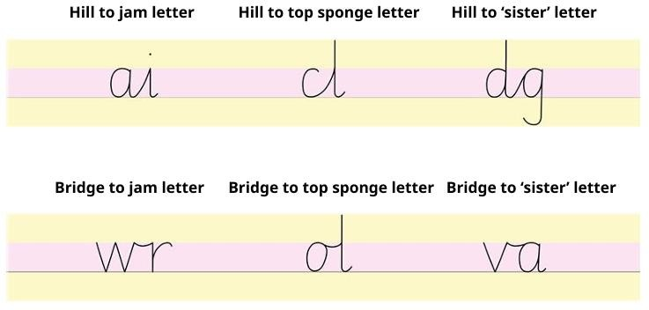
  - Children practise each join with specific letter combinations. Then they write words with the joins they have practised. We teach children that all letters are joined with the ‘hill’ or ‘bridge’ join with the exception of g, j, q, y and z.
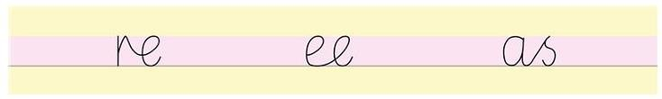
  - We modify some letters to allow them to join. For example, r, e and s:
  - Writing at this stage looks like this:

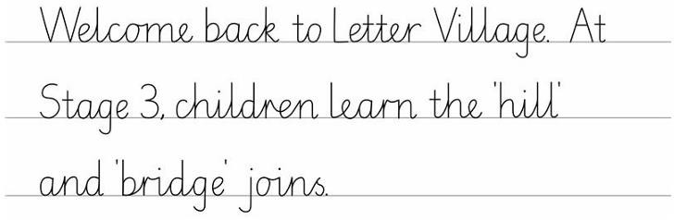
  - Use of the Read Write Inc ‘Letter Village’ programme ensures that joins are taught in order of complexity, to ensure there is a rigorous progression of skills. Joined handwriting will not be taught until children can form unjoined letters (print forms) correctly and consistently. Once children can join letters to write words, they should continue to practise handwriting discretely to develop automaticity.
  - Stage 4: Pupils develop a mature, speedy style, increasing the legibility, consistency and quality of handwriting, with the aim of increasing the fluency and speed with which children are able to write down what they want to say.

NOTE: We do not teach lead-ins and loops because…
- Lead-ins assume all letters join from the line. They don’t! Letters join from two places: f, o, r, w, v and x join
from the top, and other letters from the line
- ‘Cursive’ handwriting is synonymous with ‘joined’ handwriting. The national curriculum does not expect all letters to join. We teach a modern handwriting style that does not use ‘granny' loops! We do not join g, j and y.

Exit Level (Expected in Years 5 and 6)
  - At this stage, it is crucial that teachers are diagnostic in their approach to handwriting to ensure that children enter secondary school with a fluent, joined style. Ongoing assessment for leaning will highlight whether a return to letter formation or joins from previous stages is need.
  - Once children are secure with joining letters, a slant is introduced in order to support increased speed and fluency.
  - Teachers should then work with children to create their own individual ‘Gold Standard’ of handwriting. This should be a short paragraph of dictated writing. Using this ‘Gold Standard’ as a presentation benchmark, children should then use handwriting lessons to:
    - Increase their speed at this standard (words per minute).
    - Increase their writing stamina at this standard (increased amount of time).
  - Children should also be taught about using different handwriting for different purposes (e.g. personal note taking vs presentational writing).

It is crucial that children are secure with each stage of learning before they are moved onto the next. At Potten End CEPrimary School, children are taught by stage, not age. Rigorous assessment for learning must be in place to ensure that individual children are working at the level most suitable for their needs.

Handwriting Essentials
  - Seating and posture: Pupils sit at tables in the “perfect handwriting position”. They:
    - Put two feet on the floor
    - Push their bottom to the back of their chair
    - Tuck their chair under the table
    - Hold their pencil in a tripod grip
    - Place their other hand on their book or paper, so it doesn’t move around.
  - Equipment: Standard HB pencil (2B for early learners if needed), sharpened before lessons. Triangular grips provided where necessary – but carefully monitored to ensure that they are used in the correct way. Once children complete Stage 4 of the Read Write Inc ‘Letter Village’ programme, they then have the option of using a pen to write across the curriculum.

Writing surfaces:
    - Stage 1: Plain paper, moving onto 15mm lines / tram-lines when assessed as being ready.
    - Stage 2–3: 15mm lined or tram-lined books
    - Stage 4: 8mm lined books
  - Support for left-handed pupils: Seated to the left of right-handed peers, paper slanted to the right, pencil held slightly higher (see ‘Inclusion’ section below for more details).

Inclusion
  - All pupils are taught handwriting explicitly.
  - Additional support is provided for pupils with fine motor difficulties, including adapted pencils, grips, and targeted intervention.
  - Children with significant barriers to learning will be taught keyboard skills as well.
  - The emphasis is on quality first teaching, making adaptations within the writing lesson to ensure that all children are able to access learning, rather than to catch up through intervention sessions.

Left-handed Pupils
Writing from left to right is more difficult for left-handed children (approximately 10% of the population). They should, therefore, be given more attention in the classroom to ensure that they do not learn bad habits of position, posture and pen hold which will hinder the development of a fast, fluent and legible hand.
- Letter formation should be modelled specifically for left-handed children, by using the left hand.
- Left-handed children need to sit on the left of right-handed children, so their writing arms do not clash.
- Children should be encouraged to tilt their paper to the right rather than the left.
- Left-handed children should be encouraged to keep their wrist straight and their hand below the writing line.
- Some children might benefit from a mark being put on the left side of the page to indicate where writing begins, as some left-handed children mirror-write from the right.

Teacher / Teaching Partner Handwriting
Teacher handwriting in children’s books and during any modelled writing should model the expectations for the expected stage for their year group.

IMPACT

Assessment and Progress Over Time
- Teachers monitor grip, posture, fluency, and accuracy daily. They consider:
  - Are all letters formed correctly?
  - Are letters consistently sized?
  - Are the known joins used correctly?
  - Are ascenders and descenders parallel?
  - Are the spaces within and between words regular?
  - Is good handwriting carried over into other areas of the curriculum?
- Common errors are addressed as they arise through modelling and peer discussion.
- Progress is reviewed half termly against National Curriculum handwriting expectations.
- Next steps in learning are then planned in to ensure that children build the foundational skills in handwriting that will then support them in wider writing activities.

Handwriting Feedback
Teaching staff should give immediate feedback during handwriting lessons, modelling correct formation and joins in
children’s books before giving opportunity for them to practise.

